**Introduction**

The Kerosene Cellphone Company was accept my project proposal about Linux. The Kerosene Cellphone Company sell a cellphone products and related to the cellphones gadgets. Their cellphone product are popular in America. The company has 3 branches in the Manila, Philippines and the other one is on London America. The Kerosene Cellphone Shop started their business since 1999.

In their company, I will install linux ubuntu then, In their company, I create a 3 groups for their Departments which is Marketing Department, Electric Department and Design Department. Especially, I create 3 user for the Staff of the company which username is StaffOne, StaffTwo and StaffThree. This method the company easy to deliver files or work files wide from office work. And can configure files if this guy can have apermission to read, write ,execute or both.

**Departments:**

Marketing Department

* Rio G. Grande
* Juan Manuel C. Marquez
* Manny O. Pacquiao
* NoyNoy Aquino

Electric Department

* Vic M. Sotto
* Manny Villar Jr.
* Dick Gordon

Design Department

* Raoj Q. Laurel
* Rene Cimpatya

**Staffs:**

* John Paul P. Rorse- Marketing Department Head
* Glory K. Arrayo- Electric Department Head
* Morita S. Kaligkig- Design Department Head

**Objectives**

* To be able Install LinuxUbuntu 10.10 to the company
* To be able to create users and groups using terminal
* To be able to change the permissions of the files using terminal.
* To be able to change owner the files using terminal
* To be able to change group of the files using terminal

The Kerosene Cellphone Company need Linux because they want to get more saving, to build another new branch in the America. So I offer to them the linux, the free distribution of Operating System. The Linux have the same in Windows Operating Systems but their difference is the windows operating system is more GUI than the Linux.

**Installation of Linux Ubuntu 10.10**

**Factors to be Considered during Installation**

**System Requirements:**

**RAM size:** 3.5GB

**Hard Disk size:**  4.00 GB

**Processor Speed:** 3.00 GHz

**CD-ROM**

**Display:** 800 x 600 pixels

**Installation Process of Linux Ubuntu 10.10**

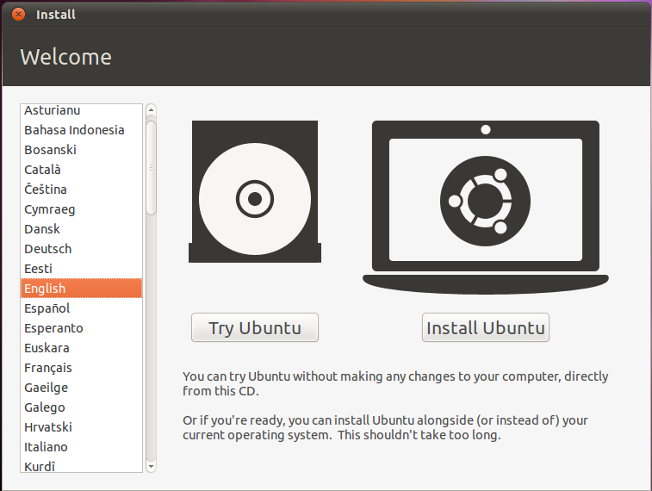

**Step1**– Choose your international language then choose

“Install Ubuntu” button. If you choose “Try Ubuntu” button

You cannot save your work in your Linux Ubuntu, while you

Choose “Install Ubuntu” button, you can save your work here.

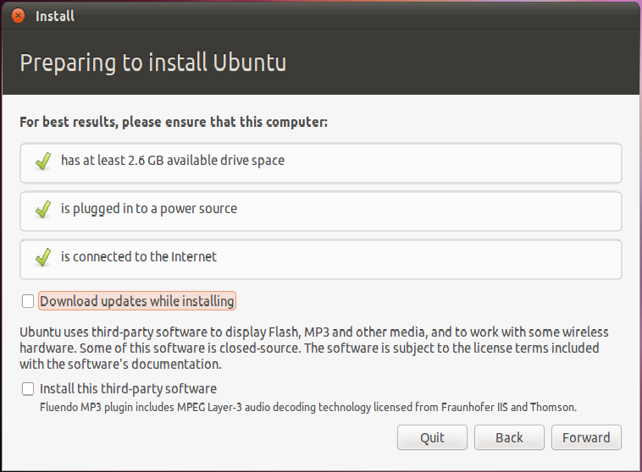

**Step 2 –** Don’t check “Download updates while installing” checkbox

And “Install this third –party software” checkbox because it is better

to download and install by using Linux Ubuntu Terminal.

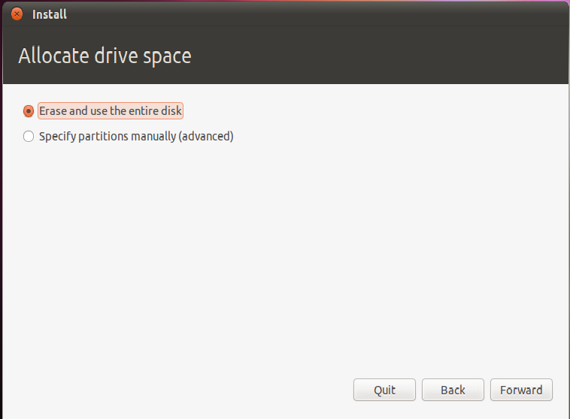

**Step 3-**“Choose Erase and use the entire disk” not “Specify partitions manually

(Advanced)” because if you choose “Specify partitions manually

(Advanced)” you set the partitions manually.

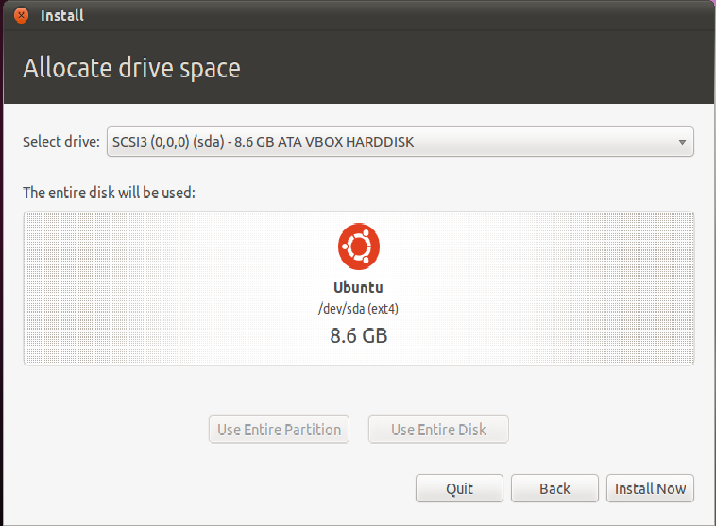

**Step 4- “**Click the Install Now” button to continue installing.

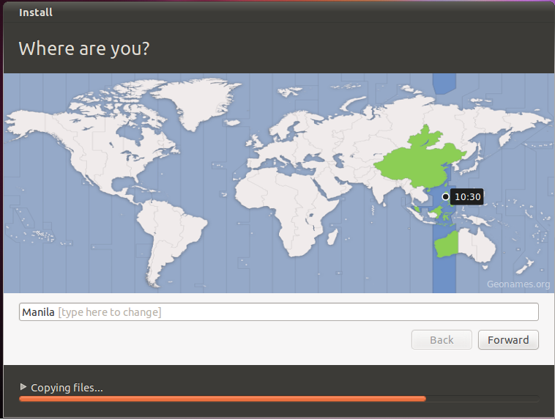

**Step 5**- Choose where you are to update time in your computer

correctly.

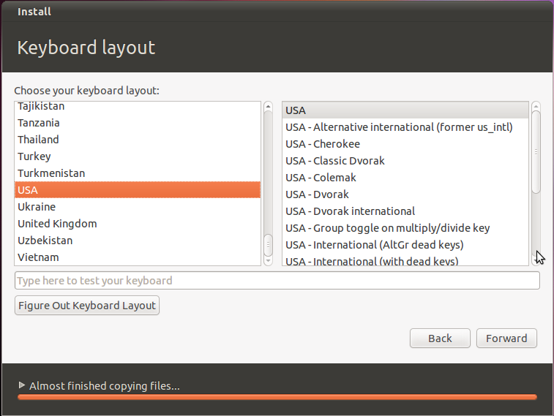

**Step 6-** Choose your international keyboard pattern then click the

“Forward” button to continue installing.

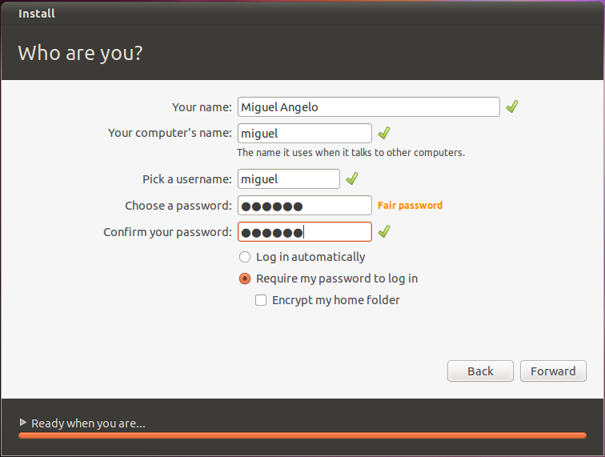

**Step 7-** Fill up the following then choose “Require my password to log in”

To require logging in to use Linux, then click the button “Forward”.

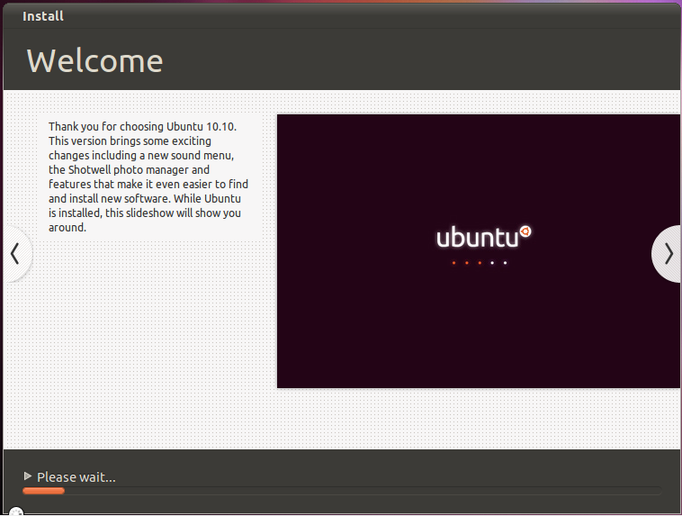

**Step 8-** Wait to install Ubuntu

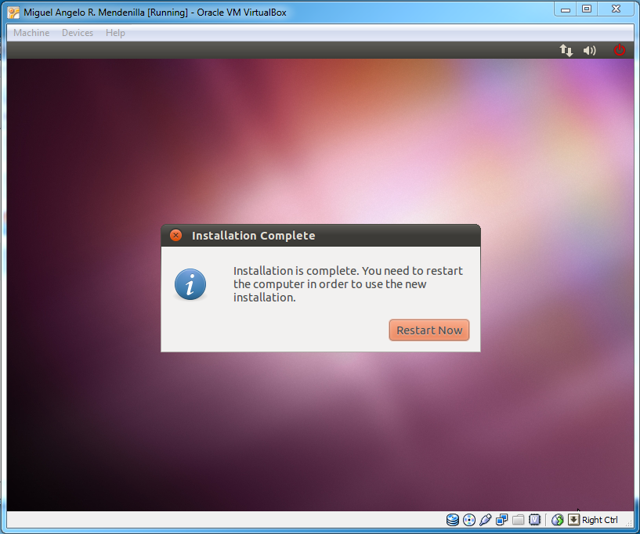

**Step 9-** Click the Restart Now button to use the new install**.**

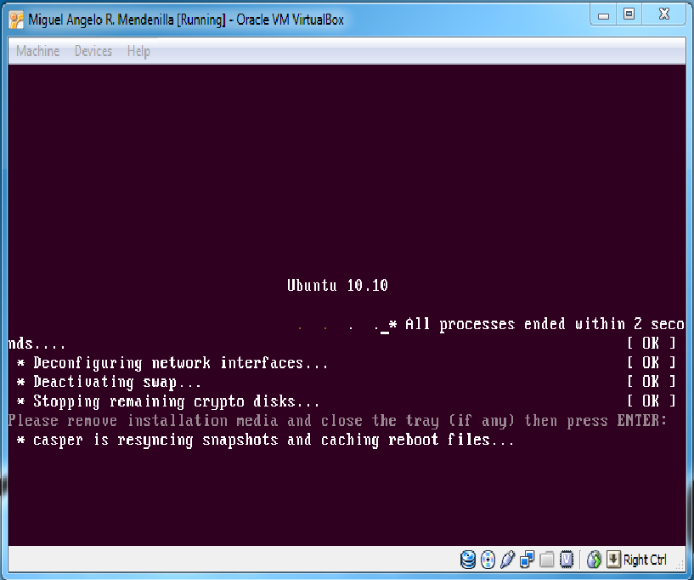

**Step 10**- Press Enter to continue.

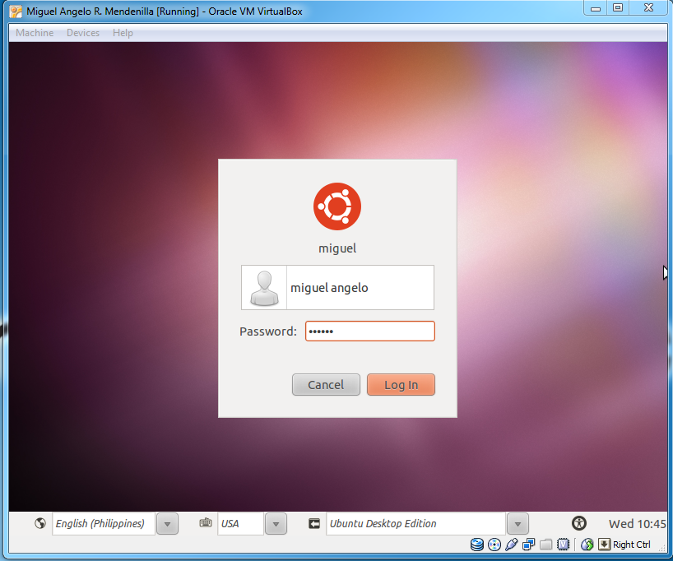

**Step 11-** Log in and enjoy using Linux

**Post- Installation Issues**

Because you’re new installed Linux has no new update and not upgrade, you must upgrade and update your new installed Linux. Using the following command, you can upgrade and update your Linux. Note; you cannot update and upgrade Linux without internet. First step to update and upgrade your computer is open first the terminal by pressing “Ctrl+Alt+T” button. Then type the following code:

Note: Small Letters only

Step 1- Type this to update your computer.

sudo apt-get update

After you type this code from terminal, the terminal displays packages and website sources and then the Linux will load instructions and downloads all packages need in Linux Ubuntu to update Ubuntu .

Step 2- Type this to upgrade your New installed packages.

sudo apt-get upgrade

#### Create Users and Groups

**How to create a user:**

First, open the terminal by pressing Ctrl+Alt +T in your keyboard. Then in creating user type;sudo adduser (new username). Then type your new password, retype new password then it have appear that say enter new value. Entering new value is optional, so you will not fill up the following information. And last, the text appear, “Is the information is correct?”, Type Y to continue creating user.

sudo adduser sampleusername

**How to delete a user:**

If you want to delete a user because it is unused or accidentally added a user, just type “sudo deluser” (new username) then the user automatically delete.

sudo deluser sampleusername

**How to create a group:**

If you want to create groups, just type “sudo addgroup (new groupname)” to create new group

sudo addgroup samplegroupname

**How to delete a group:**

If you want to delete a group because it is empty, no member in this groups or accidentally created a group, just type “sudo delgroup (groupname)” to delete this group.

sudo delgroup sample groupname

**How to add user to a group:**

If you want to add user to a group, just type “sudo addgroup (username) (groupname)” to add user to a group.

sudo addgroup sampleusername sample groupname

**How to delete user to a group:**

If you want to delete a user to a group because it is unused, deleted, or you not like this user belong to this group, just type sudo delgroup (username) (groupname)”to delete user to a group.

sudo delgroup sampleusername samplegroupname

**Policy Settings**

Creating policies in the folder and files help to give limit the user, group and others to view the folder/files.

**Departments**

|  |  |
| --- | --- |
| **Description** | **Linux Permission code** |
| **Marketing Department Folder** (d rwx r – x - - - ) | **chmod 750 'Marketing Department Folder'** |
| Rio G. Grande Files– rwx rwx rwx | chmod 777 'Rio G. Grande Files' |
| Juan Manuel C. Marquez Files – rwx rwx rwx | chmod 777 'Juan Manuel C. Marquez Files' |
| Manny O. Pacquiao Files – rwx rwx rwx | chmod 777 'Manny O Pacquiao Files' |
| NoyNoy Aquino(Files) – rwx rwx rwx | chmod 777 'NoyNoy Aquino Files' |
| **Electric Department Folder** (d rwx – r – x – r - -) | **chmod 750 'Electric Department Folder'** |
| Vic M. Sotto(Files) – rwx rwx rwx | chmod 777 'Vic M. Sotto Files' |
| Manny Villar Jr.(Files) – rwx rwx rwx | chmod 777 'Manny Villar Files' |
| Dick Gordon(Files) – rwx rwx rwx | chmod 777 'Dick Gordon Files' |
| **Design Department Folder** (d rwx – r – x – r - -) | **chmod 750 'Design Department Folder'** |
| Raoj Q. Laurel(Files) – rwx rwx rwx | chmod 777 'Raoj Q. Laurel Files' |
| Rene Cimpatya(Files) – rwx rwx rwx | chmod 777 'Rene Cimpatya Files' |

**Staffs:**

|  |  |
| --- | --- |
| **Name** | **Position** |
| John Paul P. Rorse | Marketing Department head |
| Glory K. Arrayo | Electric Department head |
| Morita S. Kaligkig | Design Department head |

**GRUB (Grunt Unified Boot Loader)**

GRUB is a boot loader package that can support up to two or more operating systems in one computer. You may allow choosing operating system during boot process, you can choose what operating system you want to use if it is in reboot mode. The GRUB will occupy error if you not correctly install the operating system in your computer.

**Common Linux Commands**(**Note**- Case Sensitive)

**pwd**- show the present working directory

**cd**- change directory

**ls**- list, show files/folders

**ls- al**- list all

**groups**- show group are you

**touch**- to create a file

**rm**- to remove a file

**mkdir**- to create a folder

**rmdir**- to remove directory

**sudo reboot**- to restart OS

**sudo halt**- shutdown OS

**sudo apt-get install**- to install new program

**less**- to view the work in file created

**chmod** - changing the permission of the user group and other account

**sudo addgroup** - addgroup - adding a group to a user.

- creating new group.

**chgrp** - changing the group member of your file.

**umask**- reverse value of permissions-default value

**Text Editor**

**vim/vi-** command line text editor

**a**-To insert text in **vi**

**i**­- To insert text in **vim**

**Esc:wq!-** To save/quit

**Esc: q!** - To quit w/out saving

**Esc**- To go to command line

**Web Browser**

**Mozilla Firefox**- the Mozilla Firefox is default web browser of Linux Ubuntu. This browser is recommended by experts. The Mozilla Firefox isfaster than the other web browser. Mozilla Firefox is easy to use because their design and it compatible to all kinds of operating systems.



**X- Window- Desktop Environment**

**GNOME** (GNU Network Object Model Environment)

Is a kind of GUI and desktop environment that you see on the top of your operating system. The GNOME is an open source software, so it is not fully develop but the REDHAT employees fully developed this software as their project to their company. This software is use for computer desktop for managing folders, files, applications, and windows task manage**.**



**Open Office**

Is create for linux ubuntu, so it is compatible to the linux. Open office has a 7 applications; Create Doc, Spreadshit, Presentation, Drawing, Database formulas and templates. This applications are supported by Linux. The other compared that the Open Office and Microsoft Office have comparison because of their applications similarities.

**Trouble Shooting Linux**

I have many encountered many troubleshooting in creating this project like the code in Linux must type in small alphabet only. The Linux is sensitive in spacing too.